System Architecture : the figure1 show software architecture of a clothing recommendation system using Model-View-Controller (MVC).

Process flow :the user interacts with the application ,the controller receives this request and request data from the model ,the model processes the request using algorithms and database. the controller receives the result and prepares them for display .

The display presents recommendation and options to the user in an easy- to-use manner

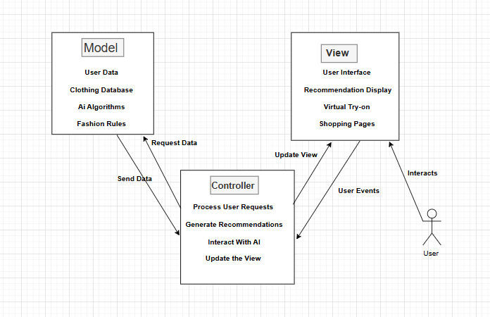

Figure 1 AI stylist architecture(drawio)